Instances created in AWS Console

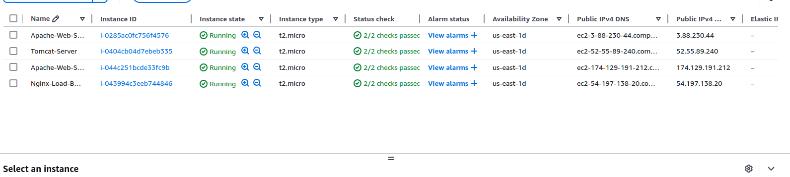

Configuring Nginx as a Load Balancer for Two Apache Web Servers
- Launched Two Apache Web Servers: Set up two separate EC2 instances with Apache installed.
- Created Unique Content: Modified the default Apache web pages to distinguish each server.
- Installed Nginx on a Separate Instance: Deployed a dedicated Nginx server to act as a load balancer.
- Configured Nginx Load Balancing: Defined an upstream block to distribute traffic between the two Apache servers.
- Enabled and Tested Load Balancing: Ensured that requests to the Nginx server alternated between Apache servers.

1. Configure nginx as load balancer for two apache webservers.

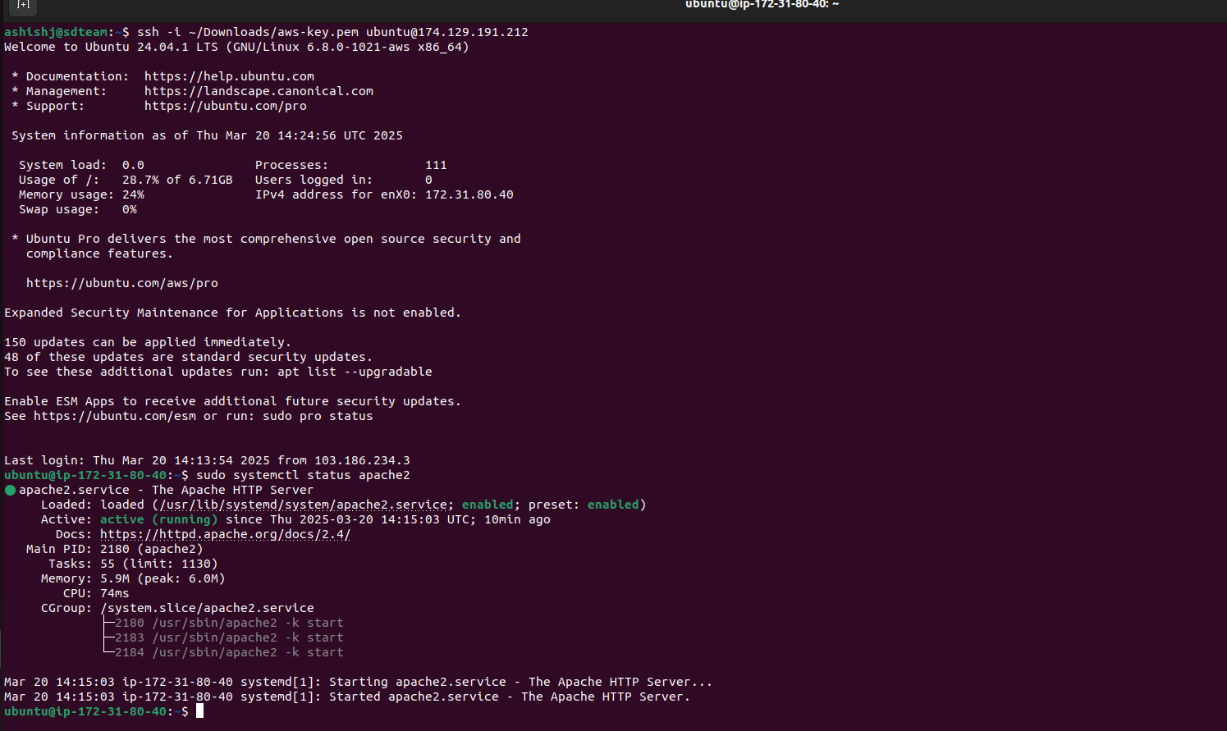

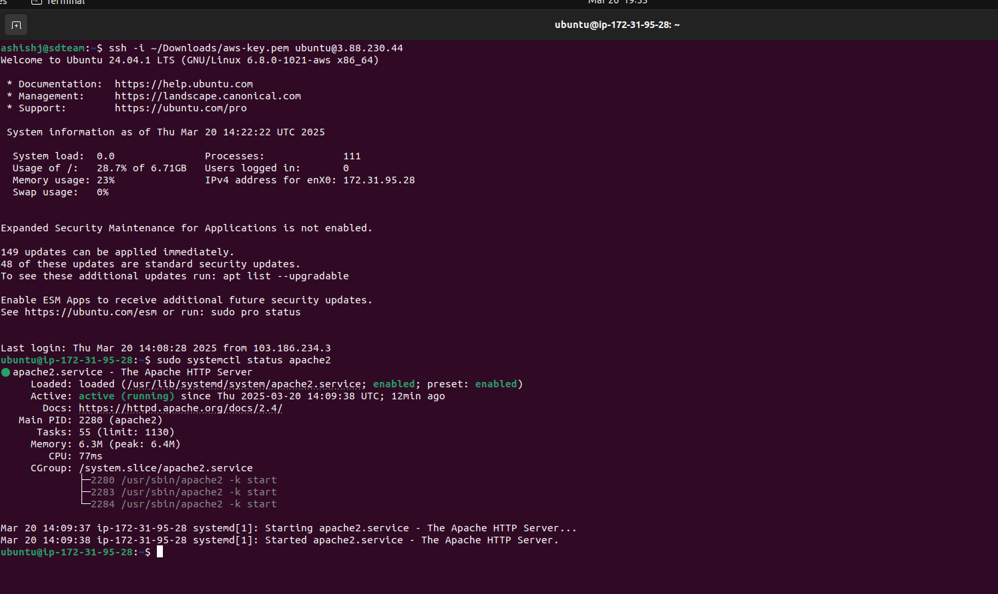

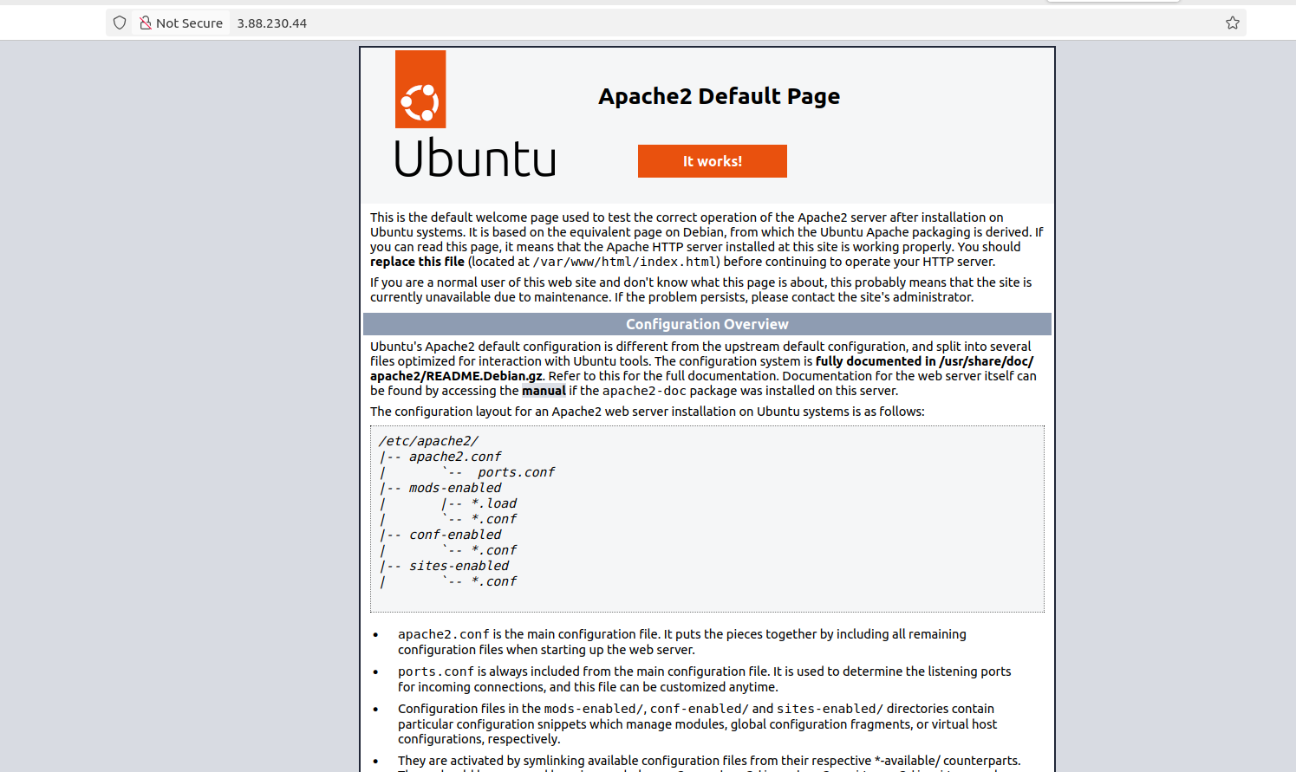

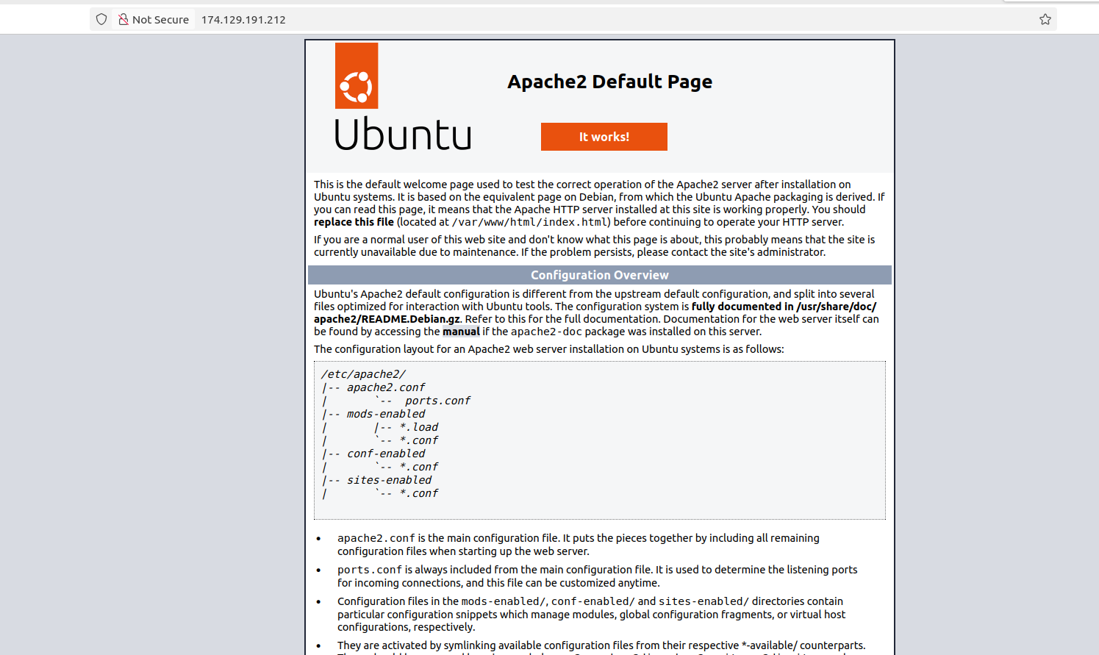

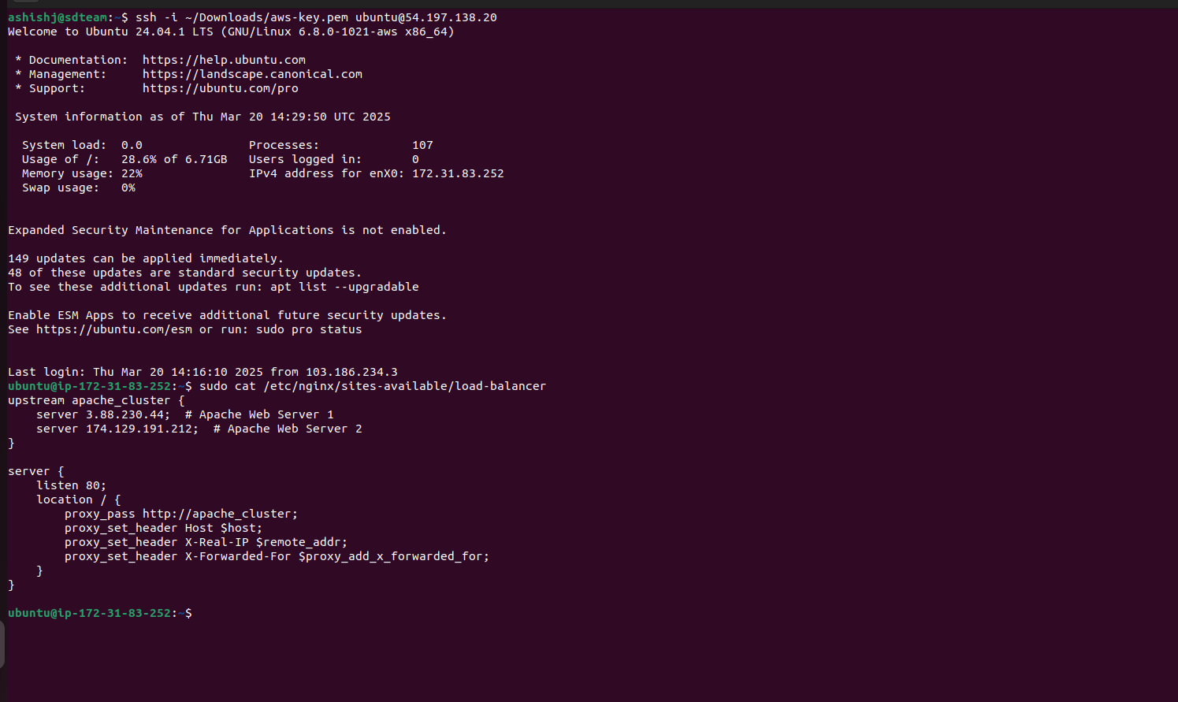

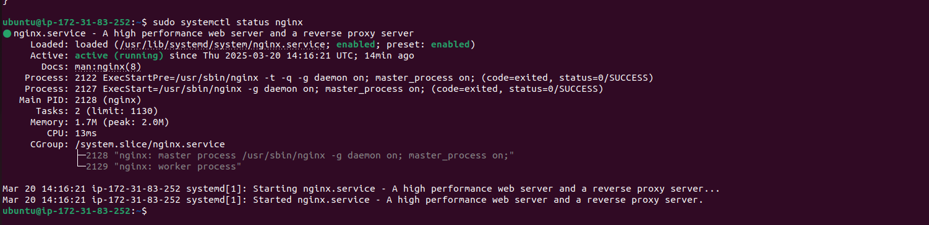

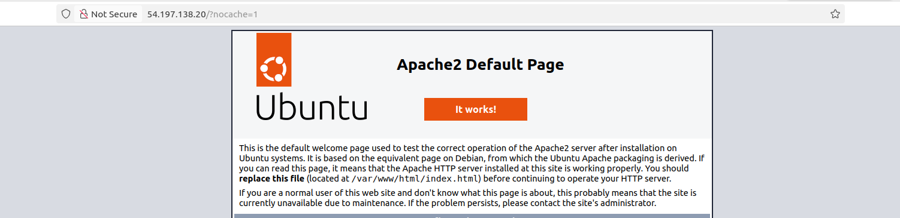

3. Install Tomcat on Linux servers.
Installing & Configuring Tomcat on a Linux Server
- Launched a Dedicated EC2 Instance: Deployed a separate Linux instance for Tomcat.
- Installed Java: Ensured the required Java environment was installed for Tomcat to function.
- Downloaded and Set Up Tomcat: Retrieved the latest stable version of Apache Tomcat and configured it.
- Started Tomcat Service: Launched Tomcat and verified it was running correctly.
- Enabled External Access: Modified security groups and firewall rules to allow traffic on the Tomcat port (8080).
- Tested Tomcat Accessibility: Accessed the Tomcat web interface from a browser to confirm successful deployment.

Tomcat Installed

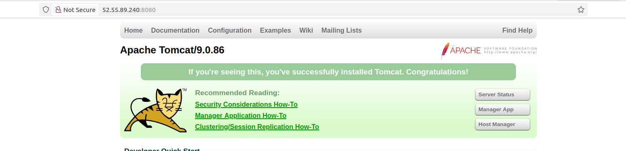

2. Configure Nginx as a reverse proxy.

Configuring Nginx as a Reverse Proxy for Tomcat
- Launched a Tomcat Server: Set up a separate EC2 instance to host Apache Tomcat.
- Installed and Configured Nginx on the Reverse Proxy Server: Created a reverse proxy configuration in Nginx.
- Mapped Requests to Tomcat: Configured Nginx to forward all incoming HTTP requests to the Tomcat server.
- Verified Reverse Proxy: Ensured that accessing the Nginx server URL correctly displayed the Tomcat application instead of Apache.

Reverse Proxy:

